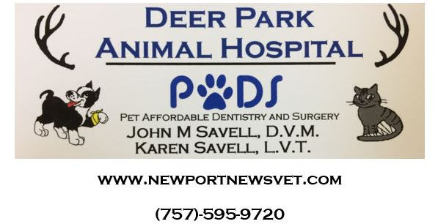
ANESTHESIA/SURGERY/DENTISTRY CONSENT FORM

___________ is being admitted for the following procedure(s) :_______________.

The veterinarian/technician will describe the procedure and answer questions and address any concerns that you may have, and describe the necessary aftercare and potential complications that may arise specific to the procedure being performed. While we use the utmost care and the safest anesthesia and monitoring protocols available, there is always an inherent risk of injury or death associated with the administration of anesthesia and performing dental and invasive surgical procedures. I also understand that unforeseen events may arise necessitating additional treatment that may become necessary. It is also unethical and professionally impossible to guarantee a completely successful outcome in every case. I understand these risks and agree to hold the veterinarians and staff of Deer Park Animal Hospital harmless.

Potential complications associated with dentistry procedures: we use ultrasonic scaling equipment to clean the teeth and then apply a fluoride-based polish to protect them. Anesthesia is required to properly examine and probe teeth for disease. Teeth will only be extracted if they are deemed to be painful, loose, infected, or causing damage to surrounding structures. The main adverse effect of an extraction is discomfort, for which we provide pain medications. Rare complications include the retention of a portion of the tooth root, infection, and in cases of very severe dental disease where tooth root infection has caused damage and weakening to the surrounding jaw bone, fracture of the jaw is possible.

Potential complications associated with surgical procedures include infection, hemorrhage, patient-induced damage to incisions/sutures, reactions to sutures, failure/breakage/loosening of surgical implants, etc. The surgeon will discuss any complications that may arise that are specific to a particular procedure. While surgery is a science, it is also an art, and it is impossible to prevent every potential complication.

I have read the preceding and agree:

Signature Date Phone No.

